

**Assignment 1**

Belo, Lea Monica 7638471   
Jin, Jinny 7545783  
Phromsorn, Nuchjarin 7157779

Desktop User Interface

# Summary

Design and implement a novel desktop user interface to launch applications for any of these PC operating systems: Windows 7, Windows 8, Linux, or OSX.

Your User Interface Design must be constrained by at least 10 guidelines outlined in the user interface design guidelines for your operating system of choice.

Your application must be able to launch at least 3 real application (ex: Calculator, Notepad, Cmd).

You must submit a document identifying how you addressed each of the 8 principles of user interface design and how you implemented 10 constraints as outlined in the guidelines for your operating system of choice. Supporting evidence for each of these must be present in your document.

|  |  |
| --- | --- |
| Marking Scheme: | |
| Addressed each of the 8 principles of user interface design | / 8 |
| Constrained user interface design using UI design guidelines | / 10 |
| Constrained user interface design using UI design guidelines | / 10 |
| User Interface is visually pleasing | / 10 |
| Implementation works | / 2 |

# Contents

Summary 1

Contents 2

Desktop Design 3

Principles 7

1. Know Your Users 7

2. Make Affordances 9

3. Map Functionality 10

4. Feedback 11

5. Use Metaphors 12

6. Forcing Functions 12

7. Automatic Learning 13

8. Context + Detail 13

Guidelines 14

1. Access functionality between multiple windows 14

2. Progress Bars 15

3. Use of mouse over effects to show that element is actionable 15

4. Use text to provide Explanation 16

5. Pleasurable to see & responsive 17

6. Keyboard Shortcuts 18

7. Use graphic elements to show hierarchy and relationships 19

8. Keep icons simple. Two icons should not share functionality. 19

9. Selective window arrangement 20

10. Cortana Voice Assistant 21

# Desktop Design

Below are the sample screen designs. The redesigned User Interface is an improved version of the Windows Operating System.

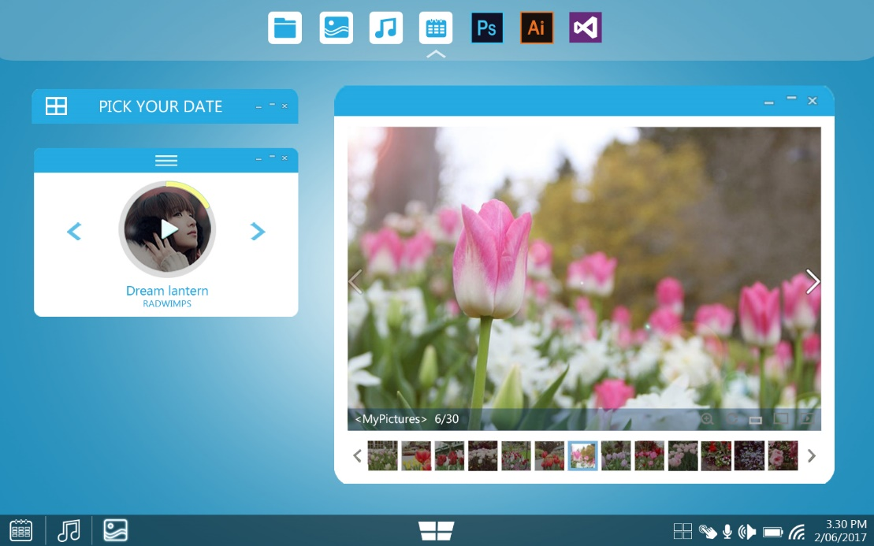

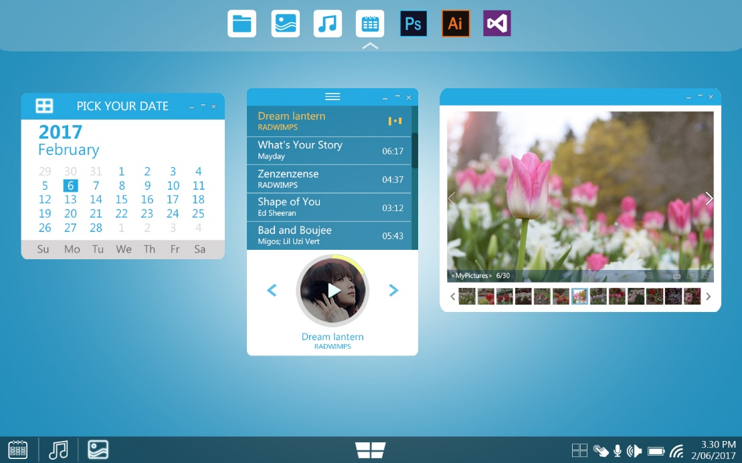

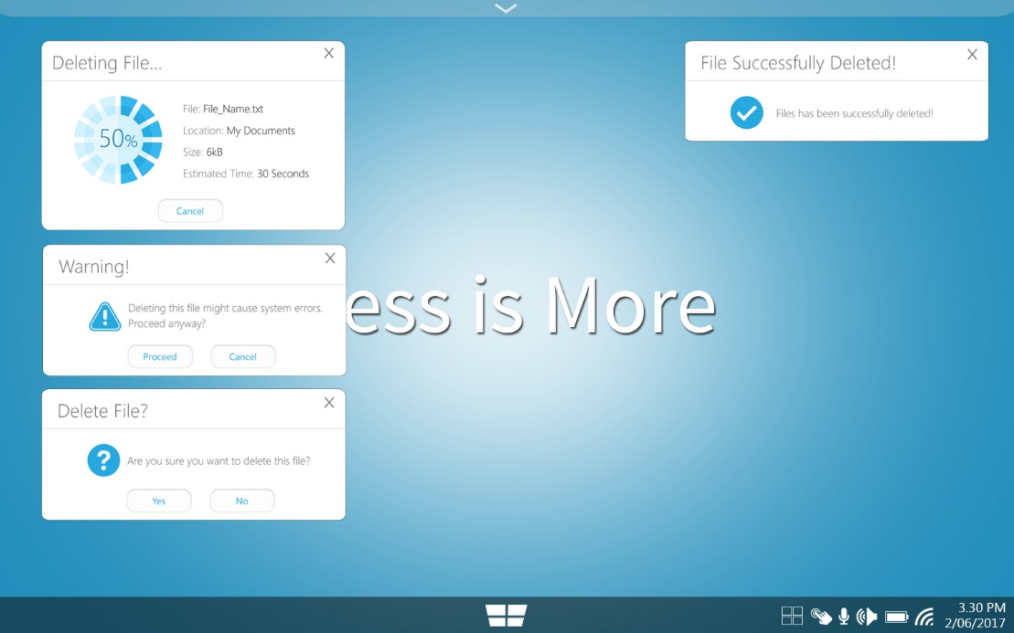

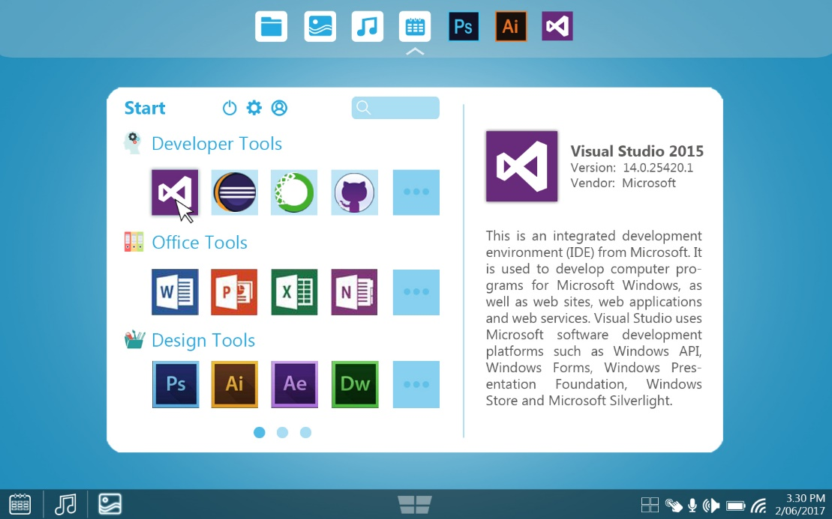

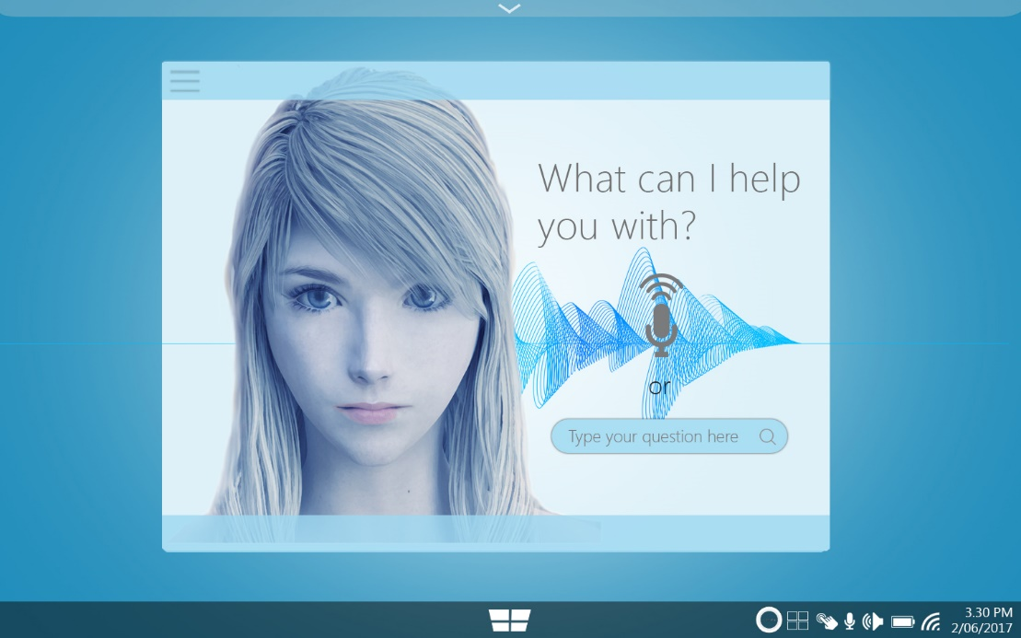

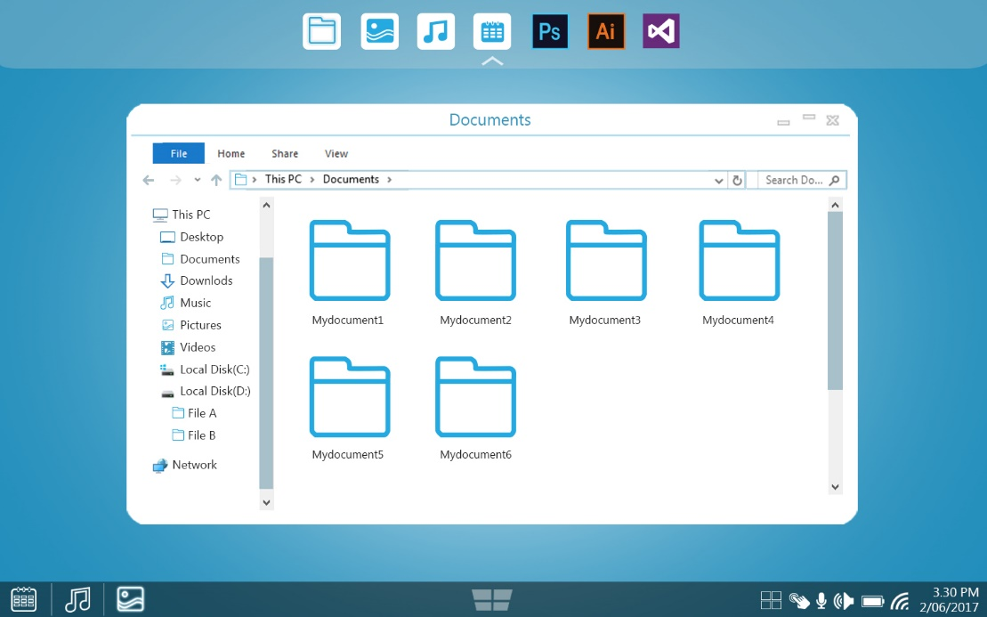

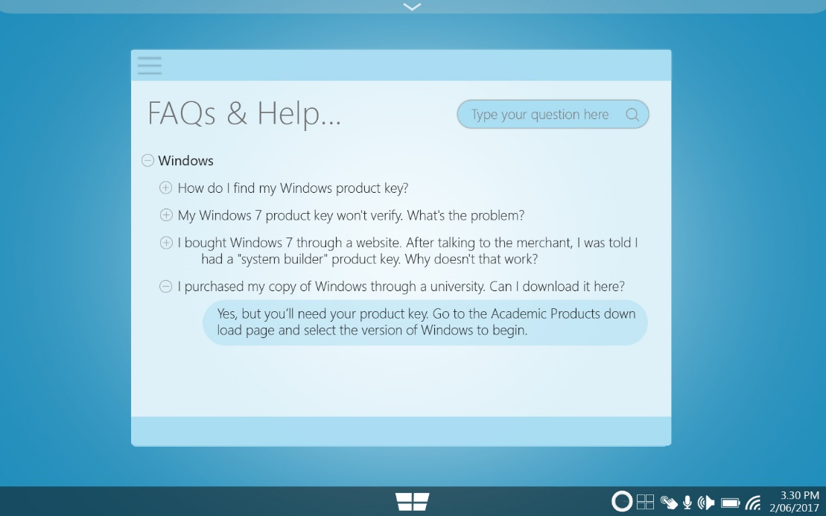

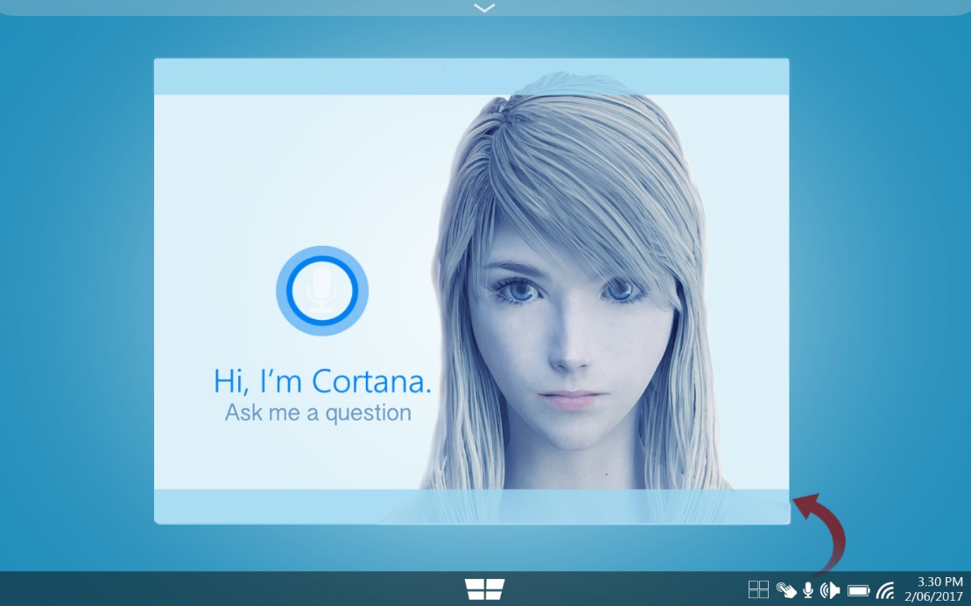

# Principles

The following principles are demonstrated or shown in the evidences attached below.

### Know Your Users

Given today’s current technology, the team opt to support multiple ways users can interact with the system. Since computers & laptops are built already with a touchpad, the system has the usual mouse input option. Second is the touch screen input, since there are also computers today that has this feature. Last is the “Cortana” user assistant. It stands as the same function as how we use Siri of ‘Ok Google’ functions. This helps improve the user experience since it acts as an assistant giving convenience to users in terms of searching for files, programs that could open a file or even send an email (like what we do with Siri). In summary, Mouse input, Touch screen, and Cortana Digital Assistant are the three different ways for Users to open the Apps.



#### Supporting Evidence:

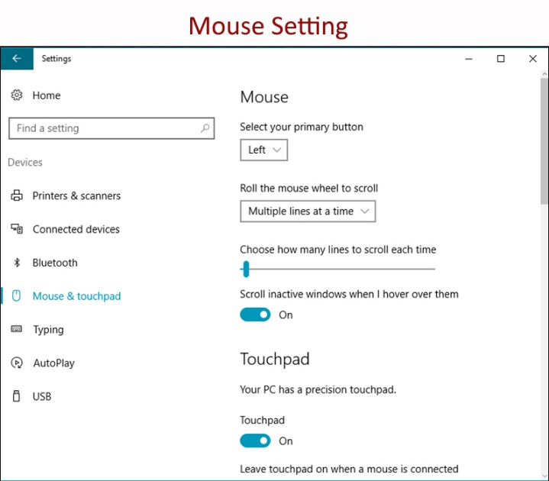

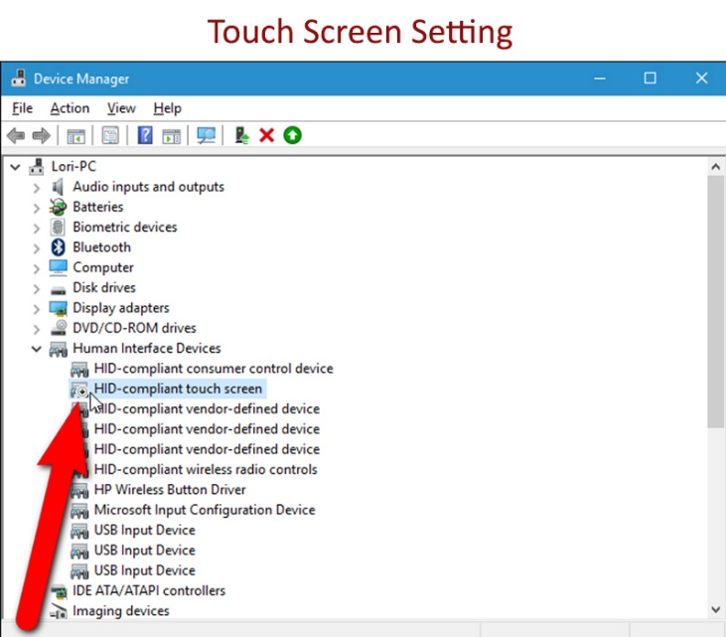

Cortana Voice Assistant Setting

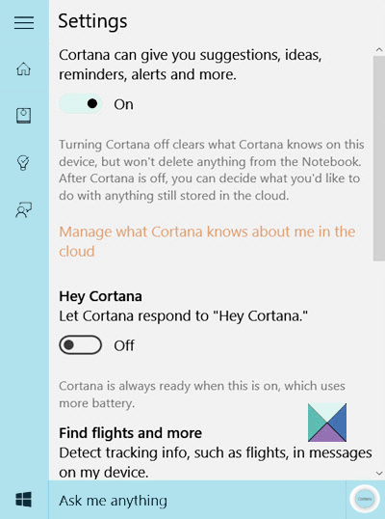

### Make Affordances

The design below shows the user the different applications he/she could use. The design used the conventional windows logo but setting it in the middle. A drawer is placed on the top portion that holds applications that a user can customize. Applications displayed in the desktop, like the music app and date app is designed in an accordion manner that could be retracted. The photo app displays the pictures in the My Pictures folder below and emphasizes on the user which photo he/she is now viewing (by darkening other unselected photos).

#### Supporting Evidence:

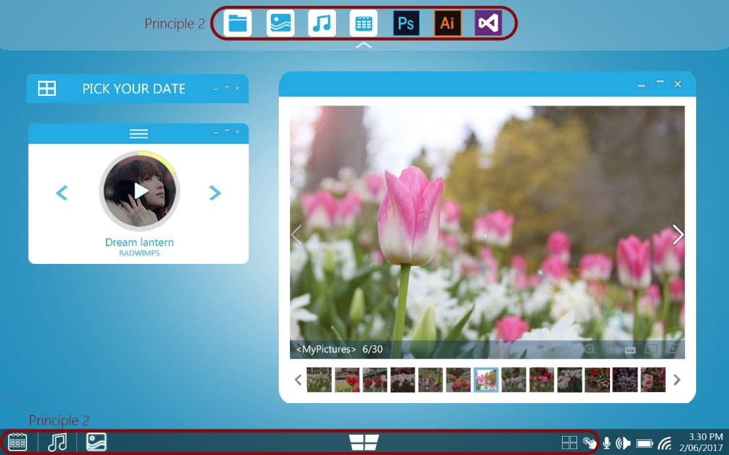



### Map Functionality

In terms of functionality, after clicking start button, the user can see the applications group per its purpose or use. When selected, the details of the application are displayed on the side. The user can opt to customize each grouping and arrange it per his/her will. A search functionality is also created to allow users to search for a specific application/file.

#### Supporting Evidence:

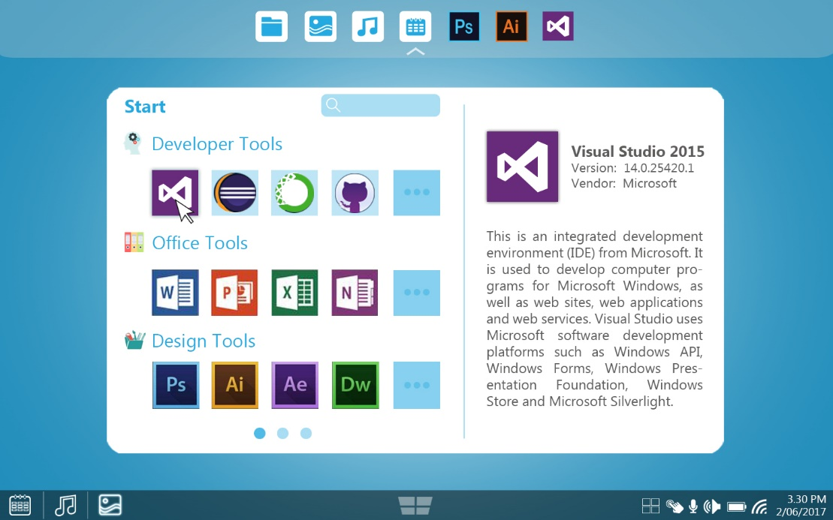



### Feedback

The feedback principle gives the user the messages/warning depending on his/her actions. If a file that is important in the system is to be deleted by a user, a warning message will show to ask for user confirmation before deleting. This warning message is only applicable to files that even if deleted, the system could still function but there is a chance of a minimal error. The same goes for normal file deletion, but a user will just be asked if he/she wants to delete the file. A progress bar is presented on the side to show the percentage of task completion.

#### Supporting Evidence:



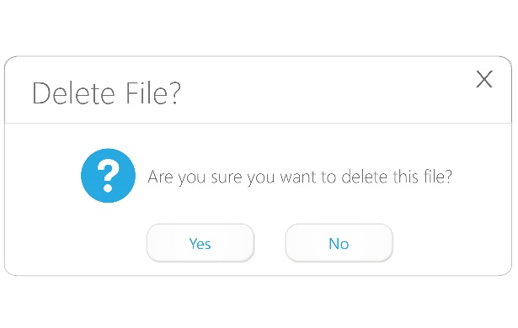 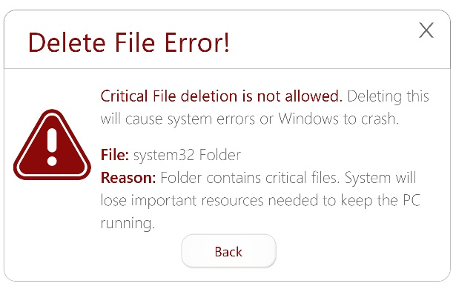

Deleting critical files is also prevented by the system.

### Use Metaphors

Using graphical symbols such as the battery, WiFi, and speaker icons which the users are familiar of.

#### Supporting Evidence:

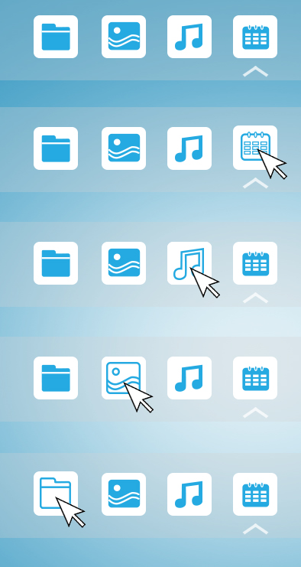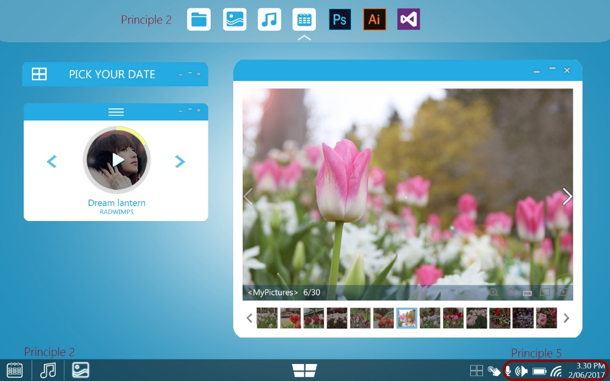

### Forcing Functions

Users are prevented from deleting critical files and are prompted about actions that would could result to errors or unwanted changes in the system. System files are also hidden unless set by user to show hidden files in the folder option. Actions such installation require user admin approval before proceeding.

#### Supporting Evidence:

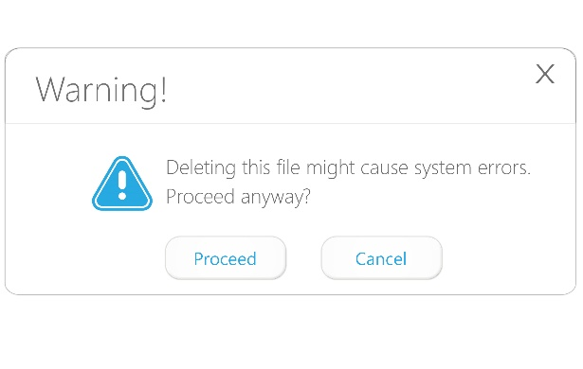 

### Automatic Learning

The file explorer structure is shown in this principle. User can easily distinguish or move about in the file explorer since it follows a tree structure.

#### Supporting Evidence:

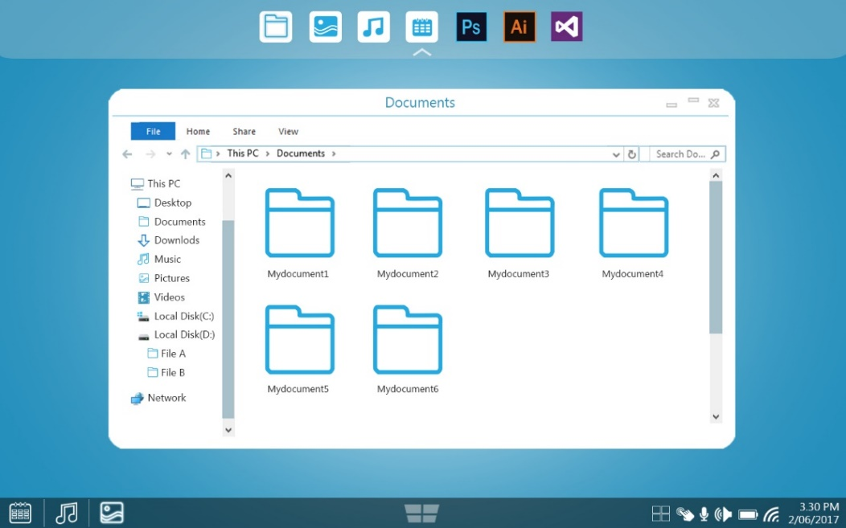

### Context + Detail

This principle is demonstrated in the picture below. User is aware on where he/she currently is. The date is highlighted, the music selected has a different color and the picture shown or currently selected is not darkened.

#### Supporting Evidence:

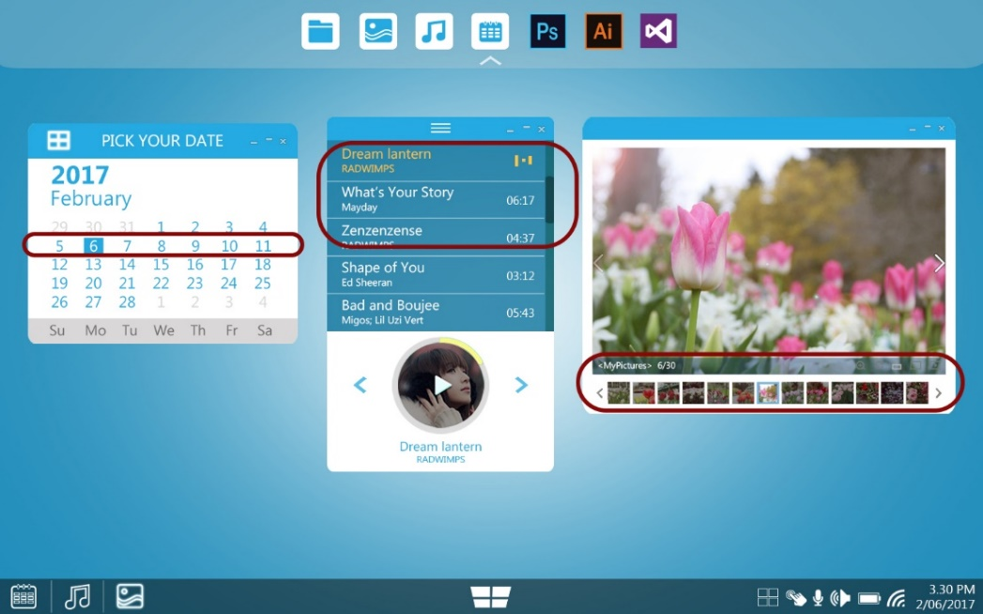

# Guidelines

### Access functionality between multiple windows

Users can change from one directory to another in the tree structure file explorer. Users can also select which windows to stack, cascade or arrange side-by-side in the screen.

#### Supporting Evidence of it being implemented:

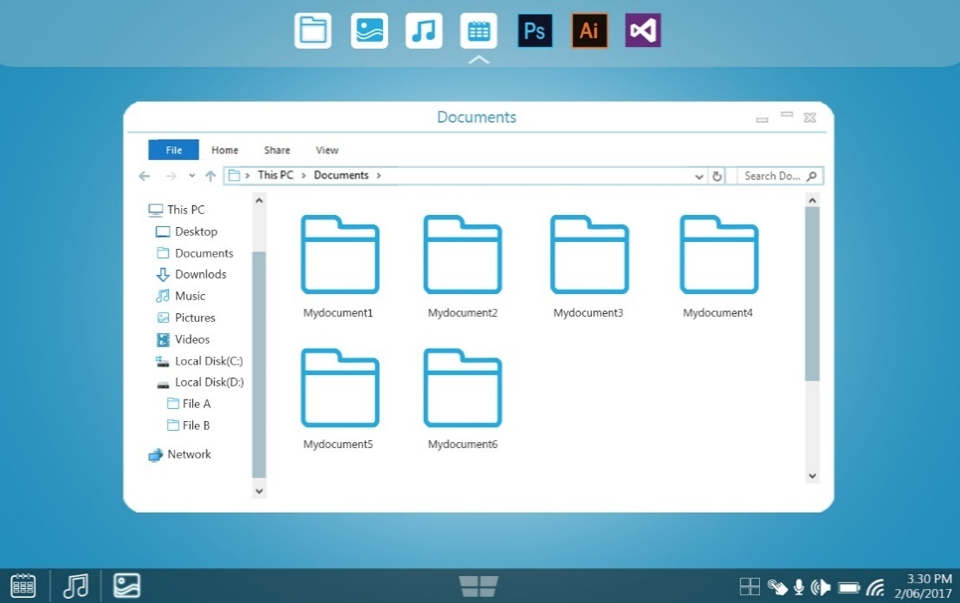

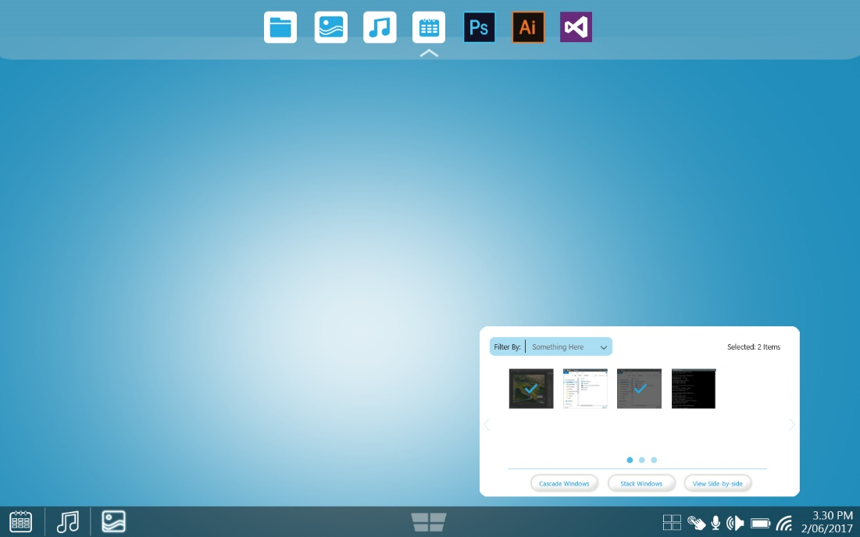

### Progress Bars

The progress bar is shown in the prompt message. Alongside the file details are the directory where to document is currently located, file size and the percentage completed.

#### Supporting Evidence of it being implemented:

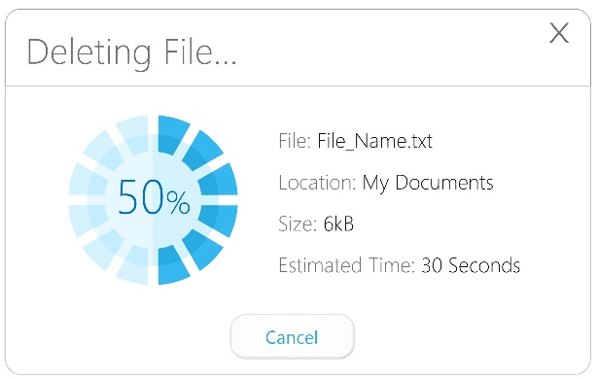

### Use of mouse over effects to show that element is actionable

The image below shows how the icon behaves on mouse over & on select.

#### Supporting Evidence of it being implemented:

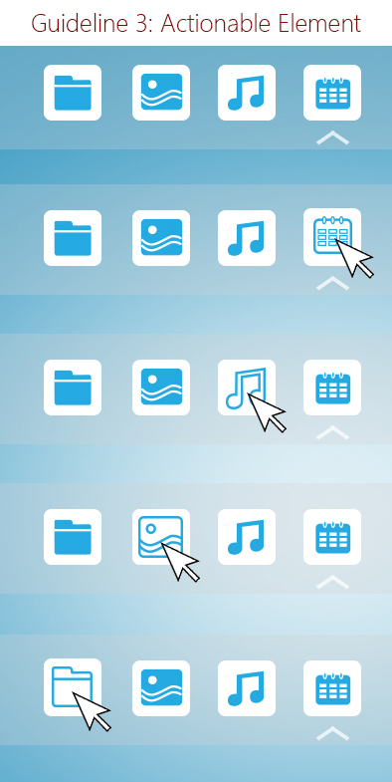 

### Use text to provide Explanation

The system has the function of F1 or Help & FAQs Functions. At the same time, user can opt to use Cortana to ask for help either by voice command or typing a question or keyword.

#### Supporting Evidence of it being implemented:





### Pleasurable to see & responsive

#### Supporting Evidence of it being implemented:

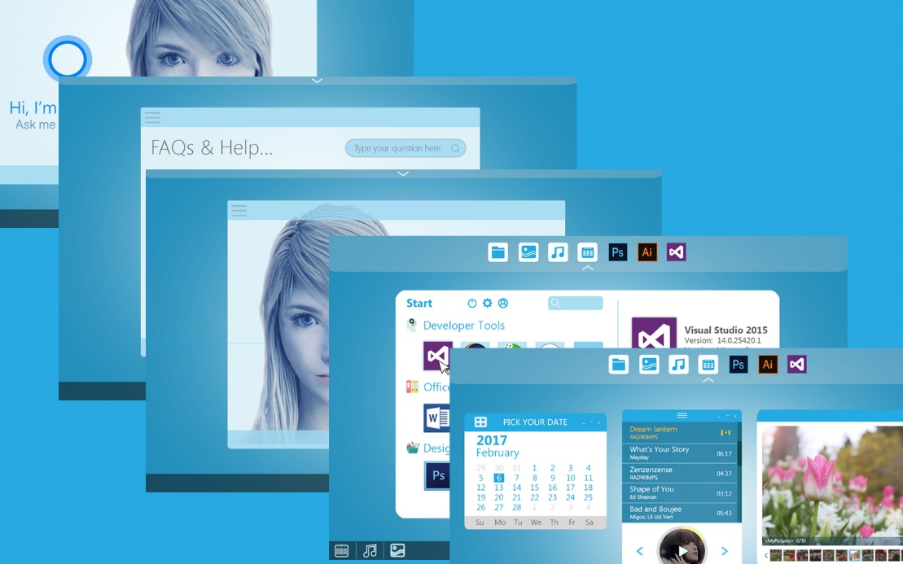

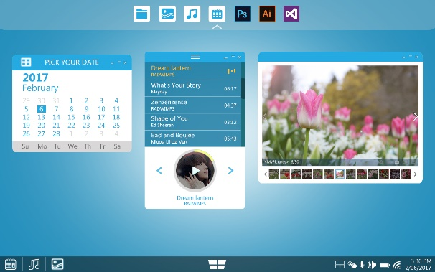 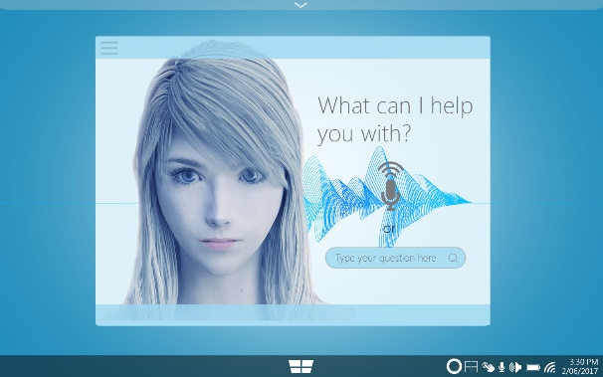

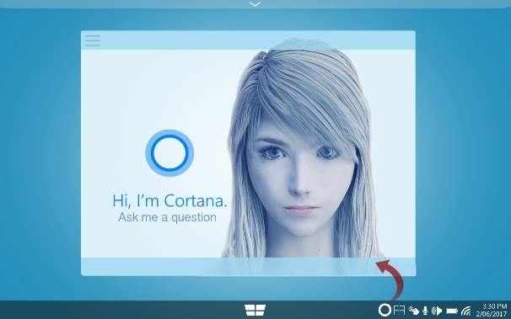 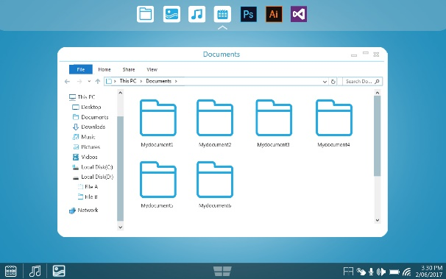

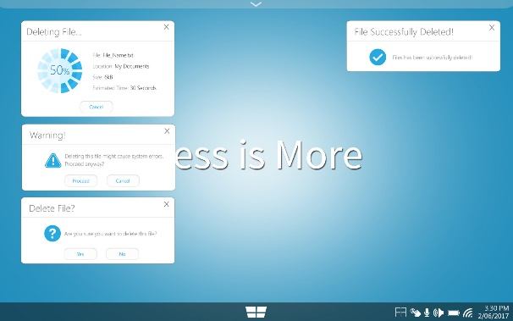 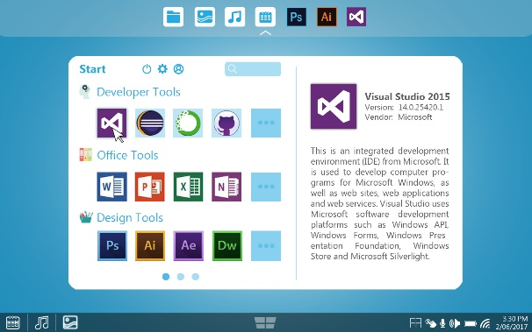

### Keyboard Shortcuts

#### Supporting Evidence of it being implemented:

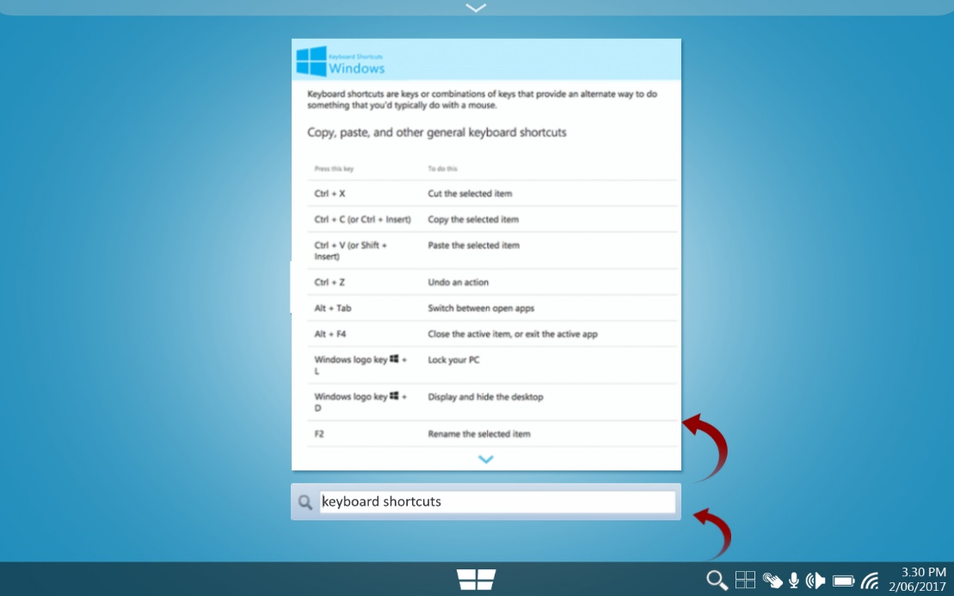

### Use graphic elements to show hierarchy and relationships

#### Supporting Evidence of it being implemented:



### Keep icons simple. Two icons should not share functionality.

Different icons were used for different functions. For Cortana , a different symbol was used instead of the microphone. Thus, the usual icons were used.

#### Supporting Evidence of it being implemented:



### Selective window arrangement

Users can select which windows to display and arrange. This suits the multi-tasking of the user.

#### Supporting Evidence of it being implemented:

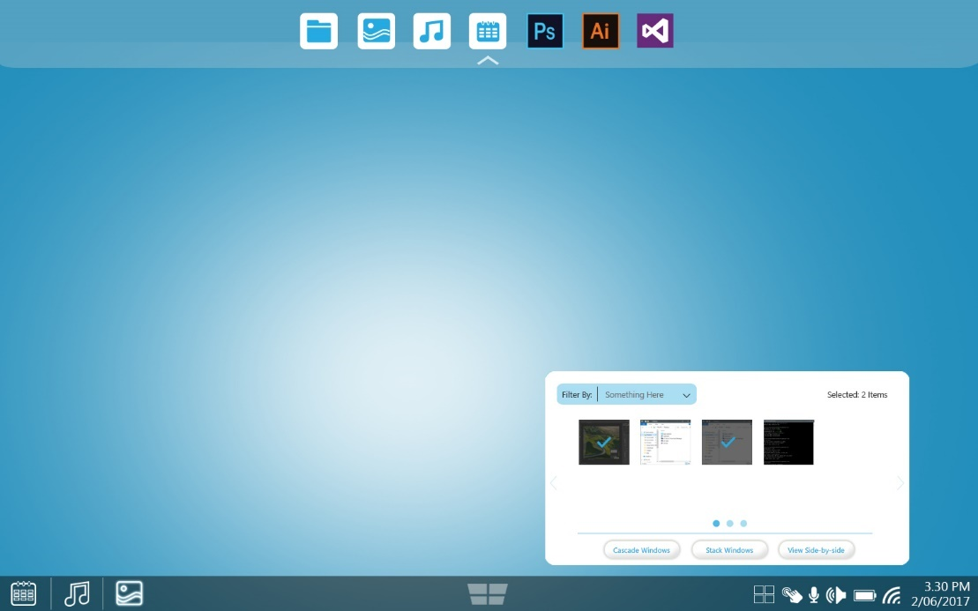

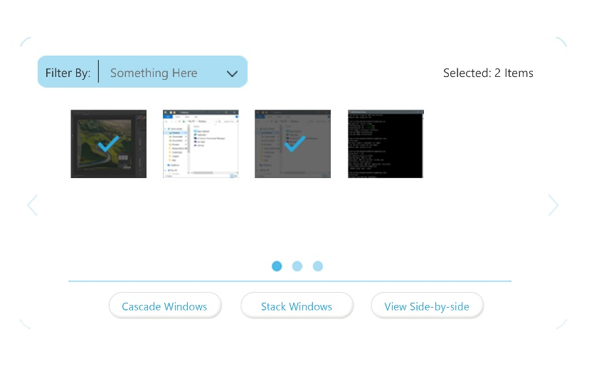

### Cortana Voice Assistant

Cortana is the true personal digital assistant and helping user to get things done by using voice commands, there are many more features to play with it. For example, User can choose how Cortana character could look likes etc.

#### Supporting Evidence of it being implemented:

Keyboard shortcut: Windows key + C to Open Cortana in listening mode.

